**Title:** Using ICT tools to understand a short story

**Created by:** Jane Lambourne, Ingela Persson Ed, Camilla Fahlstad (Sweden)

**Short description:** In this activity, students explore a short story using ICT tools to enhance comprehension. They generate vocabulary lists, summaries, character visuals, and presentations with AI, fostering reading skills, digital literacy, critical thinking, and creative collaboration through interactive group work.

**Language activity is designed for:** English.

**Age group**:

* ☒11-18

**Level**:

* A1
* A2
* B1
* B2
* C1

**Learning outcomes:**

* Reading and understanding a text.
* Critical thinking.
* ICT skills: considering *Role*, *Task*, *Goal* and *Context* to create a clear prompt and get the right response from the AI.

**Skills**:

* Listening
* Speaking
* Reading
* Writing
* Interaction
* Vocabulary
* Grammar
* Pronunciation

**ICT tool(s) used:** ChatGPT, Quillbot, Copilot, Quizlet, Sora, Sway, Padlet, Mentimeter

**Duration in minutes:**

* 90-120
* 120+

**Will students be marked for this activity?** No, they will get a summarized assessment.

**Timing**: 2-4 lessons depending on the class

**Description of each stage of the activity:**

1. The teacher chooses a [short story](https://learnenglish.britishcouncil.org/general-english/story-zone) from the British Council to work on in the group and divides students into groups.
2. Find difficult words (10 minutes)
   * Ask ChatGPT to identify the 20 most difficult words and give explanations in English presented as a vocabulary list.
   * Use a prompt. Take into consideration the following:
     + Your Role: Who are you?
     + Task: Ask it to find the 20 most difficult words for you in the text and to explain them.
     + Goal: Create a vocabulary list for Quizlet.
     + Context: To help you understand the text better.
3. Create a Quizlet with the words (10 minutes)
   * Practise with this [Quizlet](https://www.ecml.at/en/Resources/ICT/InventoryID/118) and put a link to your quizlet in your [Sway](https://www.ecml.at/en/Resources/ICT/InventoryID/115)

([Example](https://quizlet.com/se/1055023145/vocabulary-for-the-short-story-love-me-love-me-not-flash-cards/?i=xgtnz&x=1jqt))

1. Read the short story aloud in your group (10-15 minutes)
2. Summarize the text with AI and compare (20-30 minutes)
   * Use two different AI tools (e.g. [ChatGPT](https://www.ecml.at/en/Resources/ICT/InventoryID/308) , [Quillbot](https://quillbot.com/) or [Copilot](https://copilot.microsoft.com/chats/DaKyySQtYah5XuBpTmRuz)[)](https://www.ecml.at/en/Resources/ICT/InventoryID/328) to summarize the short story (exactly 100 words).
   * Compare the summaries. Look at vocabulary and content.
   * Paste both summaries in your Sway, together with an explanation of which one is best and why.
3. Choose a character from the story and create a picture with AI (15-20 minutes)
   * Choose a character from the story and create a picture with AI (15-20 minutes)
   * Ask ChatGPT/[SoraChatGPT](https://sora.chatgpt.com/explore)/Copilot to create a picture of this person. Discuss in groups and use your own imagination to give more information that isn't in the story. Examples:

* Hair, eyes, facial expression, clothes, pose, background setting.
* Check for bias—are there any stereotypes in the picture created?
* Paste this picture in your Sway together with the name of your character. 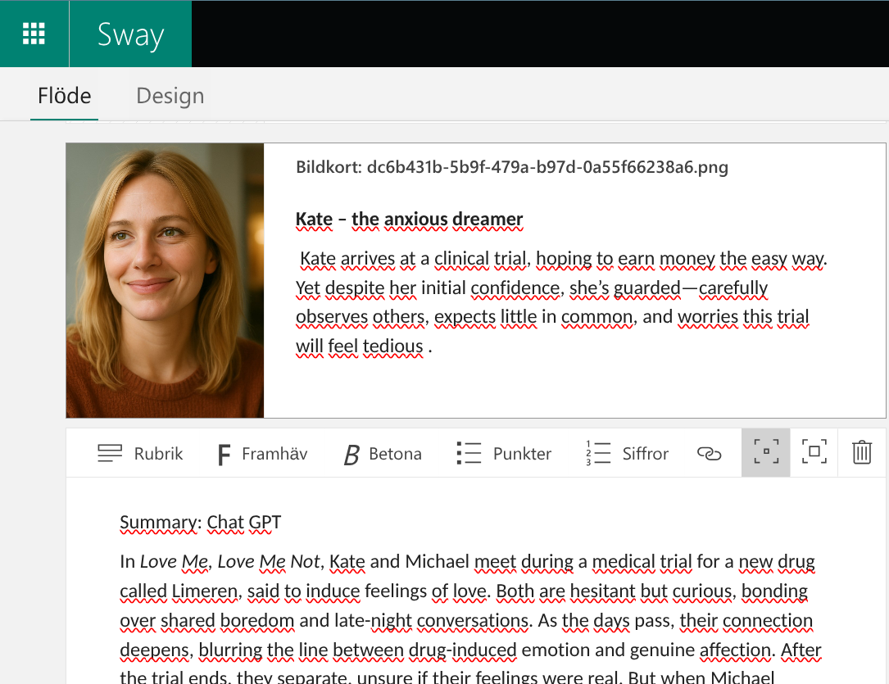

**If time allows:** **Talk to a character from the short story**

* Use AI to simulate a conversation with one of the characters in the story. This can be done by feeding the description into ChatGPT and asking it to conduct a conversation impersonating the character through ChatGPT’s audio feature. Add the conversation to your Sway if there is enough time.

7. Finish your Sway presentation (15+ minutes)

* + Edit text and choose a design, pictures etc.
  + Share the link in [Microsoft Teams](https://www.microsoft.com/en-us/microsoft-teams/group-chat-software) or in a [Padlet](https://padlet.com/auth/signup?referrer=https%3A%2F%2Fpadlet.com%2Fcreate)

1. Look at the presentations from other groups and give feedback (5 minutes)
2. The teacher uses a Quizlet Live to see if students have succeeded in learning vocabulary (10 minutes)

10. [Mentimeter](https://www.ecml.at/en/Resources/ICT/InventoryID/164) as an exit ticket with the question "What did you learn from this project?" (5 minutes) - ([Example](https://www.mentimeter.com/app/presentation/alp6vfx3z1xxjqq7xn9rnxfaxryvybgm/edit?source=share-invite-modal))

**Potential challenges/problems:**

* Yes:
* ICT skills vary between students
* Quillbot requires login for longer texts
* Quizlet has restrictions depending on account type
* Creating pictures sometimes takes too much time

**Post-evaluation of the activity**: Parts 7 and 8 above

[](https://creativecommons.org/licenses/by-nc-sa/4.0/)

Attribution: Original activity from “Use of ICT in support of language teaching and learning (ICT-REV)”, European Centre for Modern Languages of the Council of Europe. [www.ecml.at/ictrev](http://www.ecml.at/ictrev)